Important notification about your Tax deducted from salary from City of Anjo

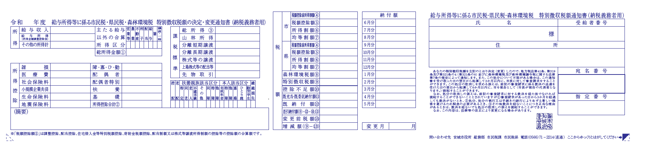

Tax amount deducted from salary. You don’t have to pay for it yourself.

If the tax changes in the middle of the year, it will be listed what month it will change.

The monthly deduction amount will be listed.

Payment will be made 12 times from June to May of the following year.

Please contact us if you are not sure.

Anjo City Hall Municipal Tax Section (North Government building 2nd floor counter 50) DirectPhone 　0566-71-2214

E-mail　 shiminzei@city.anjo.lg.jp

One of the following or blank.

「同一生計配偶者 有」

→If your total amount of income is over 10 million yen and your spouse is dependent, it will be listed.

「住宅借入金等特別控除額」

→It will be listed if mortgage deduction is applied.

「寄附金税額控除額」

→It will be listed if there is a donation tax credit including Hometown Tax